Opdracht Modifiers & more

The Access Modifiers : The access modifiers in Java specifies the accessibility or scope of a field, method, constructor, or class. Access modifiers are used to set the accessibility (visibility) of classes, interfaces, variables, methods, constructors, data members, and the setter methods.
We can change the access level of fields, constructors, methods, and class by applying the access modifier on it.
For example,
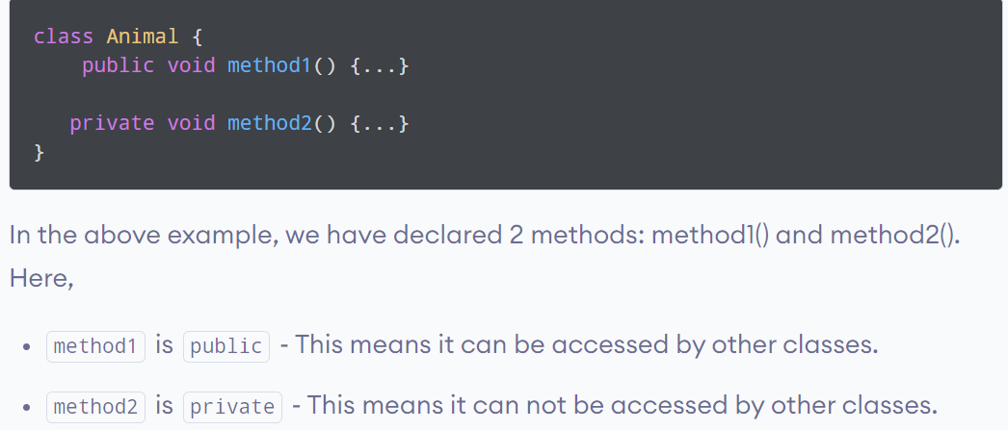
4 Access modifiers

Simply put, there are four access modifiers: public, private, protected and default (no keyword).
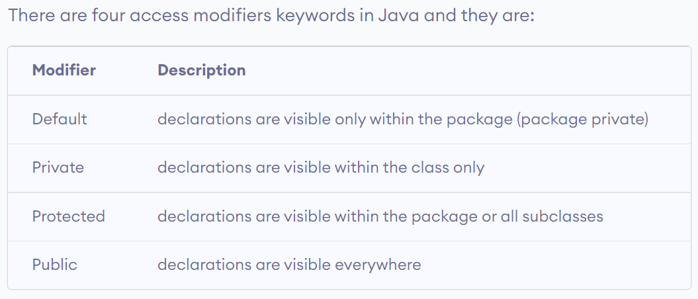
Opdracht 2
The reserved keyword for a final non-access modifier is final.
This keyword is used to make any class, method, or variable final.
Once a final variable is initialized,its value cannot be changed again.

The static variable can be used to refer to the common property of all objects (which is not unique for each object), for example, the company name of employees, college name of students, etc.
The main difference between static and final is that the static is used to define the class member that can be used independently of any object of the class.
In contrast, final is used to declare a constant variable or a method that cannot be overridden or a class that cannot be inherited.

